1. 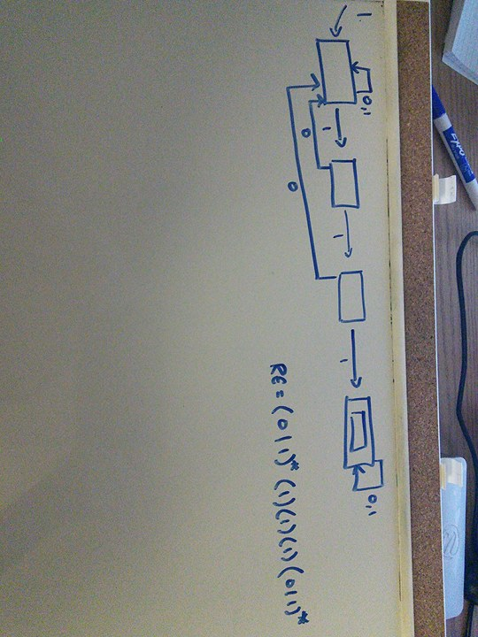A string exists in L1 if it has 3 or more 1s in a row somewhere in it.
   1. 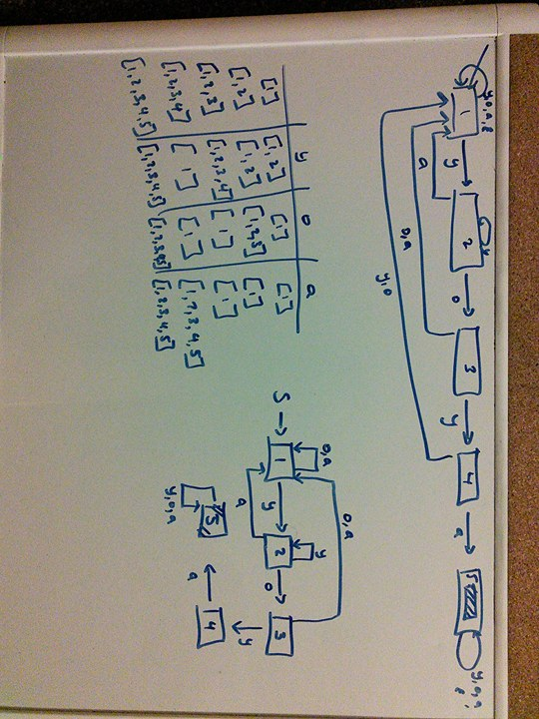RE = (0 | 1)\* (111) (0 | 1)\*
2. A string exists in L1 if it has ‘yoya’ in it. The language can only have ‘a’, ‘y’, ‘o’.
3. English translations
   1. a\* | b\* => A string exists in L3A if it is epsilon or contains any amount of a’s or b’s.
   2. (ab)\* => A string exists in L3B if it is epsilon or repetition of ab 1 or more times.
4. 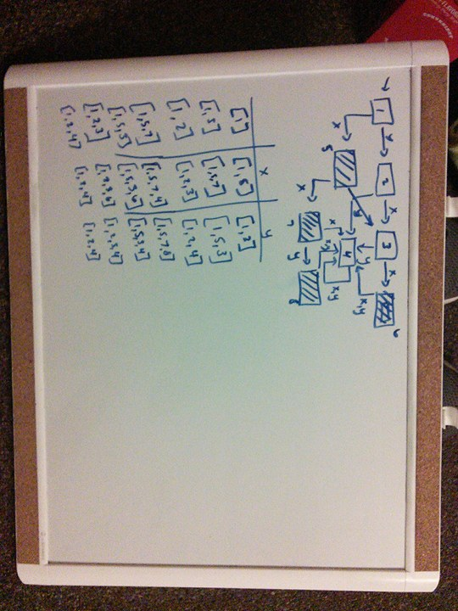A String exists in L4 if it has at most 2 x’s and more x’s than y’s.